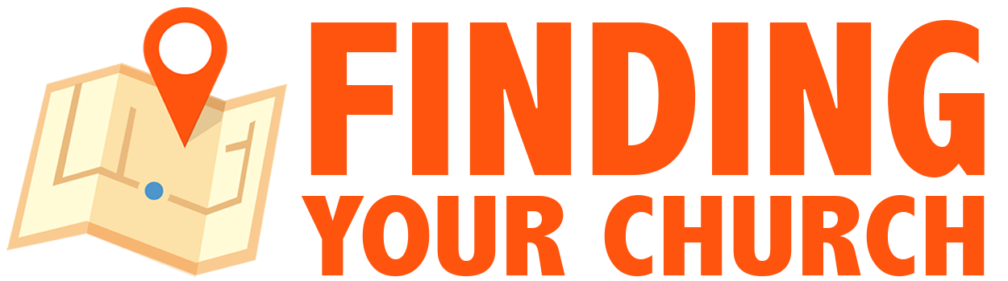
www.findingyourchurch.com

Local Promotion Resource Document
Gather all of the information below to use in Local Business Directories and consistently across your online presence.

Partner Affiliate Resources
& FindingYourChurch.com Products
_________________________

Some of these are affiliate links connected and FindingYourChurch receives a small commission
when you use the product. However, it does cost you anything extra to use the links.

Fiverr Account for Logos, Videos, Voiceovers, Graphics & more for $5
http://tracking.fiverr.com/SH1Sf

Faith Connector Websites
http://www.faithconnector.com/church-websites/JeremyPhillips285

Free Church Findability Scan https://www.cognitoforms.com/FindingYourBusiness/GetYourFREEChurchVisibilityFindabilityReport

Order 1,000 Printed Positive Review Cards
http://findingyourchurch.com/get-positive-reviews-for-your-church/the-finder-resource-members-area/google-maps-local-business-directories

Bluehost Website Hosting
http://www.bluehost.com/track/findingyourbusiness

AWeber Email Marketing
http://www.aweber.com/easy-email.htm?id=368254

Church Contact Information
_________________________

• Church Name:

• Physical Address [no PO boxes]:

• Lead Pastor’s Name or
Contact Person’s Name & Email Address:

• Phone Number:

• Fax Number:

• Additional Phone Numbers:

• Website Address:

• Church Description [2 or 3 Sentences]:

• Years Open as a Church:

• Church Hours and Service Times:

• Keywords & Locations where you want to be Found:
Start with Church and your City. But are other keywords you think people
would use to search for you? Example: Northland Kansas City Church

• Church Google+ Business Page Link [if you have one]:

• YouTube Video Link:

• YouTube Channel Link:

• Facebook Page Link:

• Twitter Page Link:

• Church Logo and Pictures
You will also need to gather your Church Logo and up to 10 pictures that
you would like to use in your Local Business Directory accounts.

Google Yourself and FIX Problems
_________________________

Google your Church to find potential information issues that need to be fixed. Add links below to sites that have information that needs to be changed. Contact the site owner or admin and delete the links from this page as they are fixed.

Starting Point to begin your Google Search
- Current & Past Church Names
- Current & Past Church Address, Phone Numbers,
& primary church Email Addresses
- Current & Past Church Website Addresses
- Current & Past Pastor and Staff Names
- Anything else you can think of…

Google Your Community for Opportunity
_________________________

Search Google for FREE places online in your Community to post information about your Church. This should INCLUDE submission links and email addresses for local Newspaper and Media Reporters for you to submit story ideas.

Every Community is different, but here is a list to help you begin your Google Search. Add the links to the SUBMISSION pages or the EMAIL ADDRESSES where you are allowed to submit the information.

- Online Local Newspaper Event Calendars
- Local Community Websites
- Local Community Facebook and other Social Media Pages
- Local Radio Station Community Calendars & Event Submission Forms
- Local TV Station Community Calendars & Event Submission Forms

Accounts and Logins
_________________________

The logins below are just to help get you started. As you work through the process you may create more. Add them to the list.

Website Hosting Login:
OPTION: http://www.bluehost.com/track/findingyourbusiness

Website Dashboard Login:

Gmail Address for Church Marketing:

Link to your Free Church Findability Scan:
[provided by FindingYourChurch.com]

AWeber Email List Building Account Login:
http://www.aweber.com/easy-email.htm?id=368254

Twitterfeed.com Login:

Hootsuite.com Login:

Canva.com Login:

Social Media Accounts:
Add links to your pages and login information below to each of your Social Media accounts. I have added a couple to get you started, but include ALL of your accounts.

Facebook:

Twitter:

Instagram:

YouTube:

Vimeo:

Local Business Directories
_________________________

Add your CHURCH or claim & optimize your existing listings on as many of these Local Business Directories as possible.

Then add the link to your completed listing and the login information for each site under the name below. Delete the websites from the list that you cannot claim or that will not allow you to create an account.

Church Directories

- Church Angel – www.churchangel.com

- Church Finder – www.churchfinder.com

- Faith Street – www.faithstreet.com

- USA Churches – www.usachurch.org

Business Directories

- Google Business – www.google.com/business

- Yahoo Local – local.yahoo.com

- Bing Places – www.bingplaces.com

- 2FindLocal – www.2findlocal.com

- American Towns – www.americantowns.com

- AMFIBI – www.amfibi.company

- Angie’s List – www.angieslist.com

- Brown Book – www.brownbook.net

- City-Data – www.city-data.com

- City Slick – www.cityslick.net

- City Squares – www.citysquares.com

- Community Walk – www.communitywalk.com

- Customer Service Numbers – www.customerservicenumbers.com

- Cylex USA – www.cylex-usa.com

- Dex Media – www.dexmedia.com

- Discover Our Town – www.discoverourtown.com

- EBusiness Pages – www.ebusinesspages.com

- Enroll Business – us.enrollbusiness.com

- Express Update – www.expressupdate.com

- Find Us Here – www.find-us-here.com

- Foursquare – www.foursquare.com

- Get Fave – www.getfave.com

- Hot Frog – www.hotfrog.com

- Hub Biz – www.hubbiz.com

- Judy’s Book – www.judysbook.com

- Kudzu – www.kudzu.com

- Lacartes – www.lacartes.com/business

- Local – www.local.com

- Local Database – www.localdatabase.com

- Local Pages – www.localpages.com

- Local Stack – www.localstack.com

- Locanto – www.locanto.com

- Manta – www.manta.com

- MapQuest – www.mapquest.com

- Merchant Circle – www.merchantcircle.com

- My Huckleberry – www.myhuckleberry.com

- My Locally – www.mylocally.com

- Rate My Area – www.ratemyarea.com
- Sales Spider – www.salesspider.com

- Seek It Local – www.seekitlocal.com

- Show Me Local – www.showmelocal.com

- Spoke – www.spoke.com

- Super Pages – www.superpages.com

- Tupelo – www.tupelo.com

- Yellow Bot – www.yellowbot.com

- Yellow Pages – www.yellowpages.com

- Yellow Page City – www.yellowpagecity.com

- Yellow USA – www.yellowusa.com

- Yelp – www.yelp.com

- Zip Local – www.ziplocal.com

